Your Personal Stylist Business Plan

**OWNERS:**

Business name: Bridge Mobile Phils. Inc.

Address: Blk. 24, Lot 9, Area 4, Sports Street,

Fourth Estate Subdivision, Sucat Road

Parañaque City, 1700

Telephone: (02) 820-1532

Fax: (02) 820 -1532

Email: bridgemobilephils1700@gmail.com

Table of Contents

Executive Summary 3

General Company Description 4

Our Service 6

Marketing Plan 7

Management and Organization 25

Personal Financial Statement 27

Startup Expenses and Capitalization 28

Financial Plan 29

# Executive Summary

Write this section *last!*

We suggest you make it 2 pages or less.

Include everything that you would cover in a 5-minute interview.

Explain the fundamentals of the proposed business: what will your product be, who will be your customers, who are the owners, what do you think the future holds for your business and your industry?

Make it enthusiastic, professional, complete and concise.

If applying for a loan, state clearly how much you want, precisely how you are going to use it, and how the money will make your business more profitable, thereby ensuring repayment.

# 

# General Company Description

In line with present – day social issues that include dressing up for school or for a very important event, in cooperation with numerous clothing brands all over the Philippines, **Bridge Mobile Phils, Inc.,** brings you **Your Personal Stylist,** an app that lets you have your virtual wardrobe as well as your *personal stylist,* which you can access anytime, anywhere.

Bridge Mobile Phils, Inc. or **BMPI,** engages in the business of *third – party* services, in hopes of aiding the Filipino citizens in the dilemma of **finding**, **fitting** and **buying** clothes online. Technicalities aside, the business addresses the **clothing industry’s** needs, as it faces its target market – and answers these commonly – faced dilemmas faced by multiple generations. BMPI, conforms to the e-commerce act and aligns with its provisions that involve user and service – provider confidentiality, and data security.

The partnership’s **mission** is to bridge the target market with the clothing industry, while providing self–developmental, user–specific fashion guides, which may be proven to be realistic, reliable and accessible.

The company envisions itself to be a locally – recognized third – party application, until such time that it becomes widespread to possibly answer a global / international demand. This of course, may only be done by gaining the trust of the online community, and by ensuring good business rapport with our clothing partners / clients. The company’s ***goals*** include being a successful company in terms of morals and financials, and a client & customer pool that has unwavering loyalty and patronage to the business and to the app. To reach this, the partners of the business believe that the road to success should be based on *SMART objectives.* Some of these include, a gradual growth in the number of downloads incrementing during each fiscal year. Another objective, is to be able to gain positive reviews / recommendations from the initial users of the application, possibly, sufficing for a success metric for user satisfaction.

The partners believe that success not only lies in the delivery of the service, but on how the service impacts the clients and customers you engage business with. At BMPI, our business philosophy involves helping the market and bringing them closer to the clothing industry. We believe that the *first mistake* a business can make is failing to address the needs of its client / customers. Thus, the company must ensure that the **features** of our application, which yield **benefits**, are in the proper place for the market.

The company’s target market are not grounded to a specific age. The business is aimed to address all clothing / dressing up issues of people for various ages. However, inherent interest of the market is to be duly assessed, and there is a specific *propensity* of the younger market to be involved in using the application, discussed in the Marketing Plan.

The business enters the playing field of the **clothing** **industry**, and it engages in the form of a third – party application designed to **support the needs of the customer** in terms of **fashion** guidance / education, and providing the clients with the necessary **venue** for them to be able to *expose their product* more, to the **online community.**

Our company’s strengths and core competencies include the following: (1) Having a growing and realistic base for our target market and clients, as **clothing,** is a **physiological necessity** (part of *Maslow’s Heirarchy of Needs)*, (2) The needs that are being addressed by the company’s application are **inherent**, meaning, these needs have been plaguing most of mankind in the 21st Century, and lastly, (3) In line with the recent growth of the online community, and the proliferation of mobile applications, people tend to find solutions to their problems by downloading applications, which the business would like to affirm by providing them a fashion app that answers their needs, like no other.

The fashion industry is a growing industry. We cannot deny the fact that there will always be changes and evolution in *fashion and styling*. The occurrence of new trends is inevitable and maybe beneficial in the long term, but the company must learn how to adapt into these changes. The **realistic and measurable success factors** of our business include *continuous / gradual growth*of the number of downloads for the app, and its *wide usage* in the market, *positive verification* with the customers / downloaders of the app, which may be viewed in the form of reviews / critics presented in the app store, and a *confirmation* from our clothing brand partners, that the application aids in the sales of their products.

The partners in the team are composed of Information Technology graduates who specifically aimed to solve the inherent need of fashion and clothing issues for the market. Most of the team will utilize their technical skills, and an application of their knowledge from the mentioned course. Some members of this partnership are also familiar with fashion blogs and constantly follow fashion bloggers, this might have also served as a motive to create the startup.

As insinuated in the previous statements, the legal form of ownership that **Bridge Mobile Phils, Inc.,** follows, is that of a **Partnership.** The proponents of the startup specifically chose this idea because the technicalities of setting up a partnership establishment are quite minimal. Start-up costs are low, and through this we may gain more capital for the business. Another important factor to note, is that by forming a partnership, we have obtain a greater *borrowing* capacity, which in truth, is a necessary means to start the business.

This business plan has been created specifically for the benefit of attracting angel investors and potential venture capitalists who are looking for a startup to invest on. The benefits and the return of their investments will be discussed in detail within this plan.

# Our Service

**Your Personal Stylist** is a mobile application that makes dressing up fun, fast and easy. It is intended for men and women, of various ages who are having a hard time choosing what to wear every day and for different occasions that they need to attend. It directs consumers to local stores and allows consumers to purchase directly from their phones.

Ideally, Your Personal Stylist **(YPS)** will partner with popular labels such as *Bench, Penshoppe, Oxygen, etc.*, along with selected foreign labels. Ideally, it’s set to be used in the Android Platform, for a larger target market. There are two type of users: Free and Premium, all of which have various different benefits that will be explained in detail in the marketing plan.

The following may be considered as competitive advantages in our industry:

1. **Growing industry –** The fashion market is an ever – growing playing field for those who choose to engage in its business. Trends are always just around the corner, and rapid changes to adapt to these trends are necessary. **YPS** does that. It helps clothing brands shift and adapt to these trends by presenting their latest fashion items to its market, all the while, exposing their items which may in turn, boost their sales for the market. The app also helps guide users into selecting and choosing the fashion trends that may best suit them.
2. **Level of investment –** The public would mostly be surprised at how much some people are willing to invest on their personal fashion. The company believes that this unique niche in the market of providing fashion tips, and backing these tips up with real life products, while being able to test how it would look on your body type, would most definitely be able to justify the investments that they would provide in availing of the service.
3. **Unique Proprietary Features –** Some important features to note are the following: (1) Users can be able to see how it would look on their body types, (2) users will be able to receive suggestions and guidance as to what type of fashion style may fit their body types, (3) users will be able to select items for purchasing, similar to online transactions done in most clothing brands’ online shops, (4) users will also be able to verify, whether a certain item with a specific size, or color is available in a specified location, of course, with a guideline to the duration of identifying supplies, etc.

The pricing of Php 100.00 for the Premium App was based on a survey the proponents conducted, on how much prospect customers would be willing to invest on a fashion app. Prices for in – app purchases (e.g. Wardrobe extension, fitting capacity), for those with the Free version were estimated based on a percentage of the Premium version.

# Marketing Plan

## Market Research

To completely accomplish the marketing plan, the proponents of this business plan have come up with various researches which were used in the succeeding segments. A summary of these researches may be viewed in the appendix.

This market research are composed of the following:

Primary Market Research

* Surveys conducted by the proponents
* Studies conducted by the proponents
* Analysis by the proponents

Secondary Market Research

* Articles from the Internet
* Studies conducted by researchers

The following market researches, both primary and secondary are to be discussed finely in detail in the succeeding segments.

## Economics

The business of the company involves engaging with the Clothing industry. The Fashion market in the Philippines can be labeled as ever – growing. In line with this, the proponents of the business plan, aimed to obtain an achievable and tangible number for the idealized target market.

The proponents used public business data provided by one of our competitors, *Zalora,* which presented a number of 1,000,000 – 5,000,000 number of installs within their past 3.5 – 3.7 years in the industry. This is valuable data and can be assumed as an integral part in identifying various related information that can affect the analysis of our business. From this 5 Million number of downloads, a certain margin of assumption can be derived that not all of them kept the app (some might have just downloaded it in a phone, but it has not been used), so arguably, we used the data of 5 million, as an assumptive data to obtain the number of possible downloads we will get during our first four years in the industry. This analysis will be described later on in the business plan.

To be able to assess our space in the market, we cannot directly say that we will take away the customers that Zalora, and other fashion, online shop apps, presently have. However, we believe that it is possible for customers to use other fashion apps, in sync with our mobile app. We believe that if we cannot necessarily take customers from them, we can share some of them.

In line with the current demand from the target market, the data of 5 Million downloads for Zalora, and an average of 40,000 customer reviews, we believe that the current demand for side apps that have fashion services are high. The trend in the fashion market is always within a certain margin of variety. Fashion trends come and go, however applications who serve them on the customer, in a silver platter, do not. This may be a source for an analysis that there is growth potential for applications that engage the fashion industry.

In every business, there will always be barriers for entry. Some of these barriers that the partners foresee for the business are listed below:

* Pioneering technology – being the first to create an application in the industry does not necessarily give you competitive advantage, sometimes, all it takes is a mistake, and somebody else might take your place
* High marketing costs – marketing will always be an issue for startups since most Consumers / Customers are not necessarily acquainted with the application yet, thus an issue of acceptance/brand recognition may arise

The following are some of the strategies we intend to perform, to mitigate the fore-mentioned risks:

* Establish rapport within the industry (clients and customers)
* Make sure that the application is secure
* Secure the necessary trademarks, copyrights or patents for the said technology
* Balance the costs that will be incurred for marketing
* Take advantage of startup expositions to make sure that company / app gains exposure

Some factors about government regulations and policies that may affect the business are listed below:

* Government regulations
  + The government has strict policies and regulations in accordance to what third – party applications can and cannot do. Some processes, although seemingly innocent, may be taxed
  + The following must be ensured:
    - An understanding of government policies with taxable and non-taxable business processes
    - Establishing a good profile with the government in accordance to the business’ compliance with regulations
    - Properly declaring all assets and liabilities as required by the government

## Service

The service provided by Your Personal Stylist are discussed in detail below.

### Features and Benefits

The following are some functionalities that the app may provide for the Free and Premium Users:

**Free Users**

* Will be given a default lists/a limited set of outfits
* Can upgrade their account into Premium to get added features
* View the calendar and see proposed outfit for the day
* Receive tips and suggestions about cost – effective shopping
* Can only fit either top or bottom one at a time
* Receive notifications about the newest fashion
* Can use occasions, events & celebrations as a filter for searching outfits
* Can use style / themes as a filter in searching for outfits
* Can purchase items online (add items to bag / cart )
* Can choose between the following payment options: Credit card/debit card, paypal
* Can fit limited sizes of the clothes they have picked
* Can read and write reviews
* Can view the brand and price of the item
* Can view the size and design of the item, and will be given a specified time for branches’ verification of availability

**Premium Users**

Premium users has the same privileges as Free Users with additional features

* Can see other people’s profile
* Like, share button will become available
* Can freely change the sizes of the clothes they have picked
* Can choose between the following payment options: Cash On Delivery, Credit/Debit Card, paypal
* Can track orders
* Can purchase items online (add items to bag / cart ), with the option of deciding the location of the pickup / delivery
* Can fit both top and bottom at the same time
* Can specify their color preferences for more precise selection of clothing
* Can plan in advance, what to wear, when to wear, and where using Calendar
* Aside from the default list, Users can also upload personal items from his/her wardrobe (personal collections)

The following table summarizes the Pain Points (needs to be answered, in the first person point of view), the features, and the benefits.

**Table 1: Pitch Canvas**

|  |  |  |  |
| --- | --- | --- | --- |
| Pain Points | Features (Free Users) | Features (Premium Users) | Benefits |
| 1. I have difficulty in identifying what to wear each day because: | * Will be given a default list/a limited set of outfits * Can upgrade their account to PREMIUM for added features | * Aside from the default list, Users can also upload personal items from his/her wardrobe (personal collections) | * Users will have various options of outfits to wear each day * Users will be able to see how their wardrobe synergizes with other clothing * Therefore, users will have the convenience of choosing what they can wear each day |
| * 1. I don’t have the time to prepare | * + Can view the calendar and see proposed outfits for the day | * + Can plan in advance, what to wear, when to wear, and where using Calendar | * + Users will be given the option to follow outfits for the day, or to plan in advance |
| * 1. I don’t feel confident with my / their fashion sense | * + Can also receive notifications about the newest fashion trends and news | * + Can also receive notifications about the newest fashion trends and news | * + Users will be informed & educated by the provided fashion trends/news, thus leading to a better fashion sense |
| * 1. I find engaging fashion as *luxurious* and expensive | * + Can also receive tips and suggestions about cost – effective shopping | * + Can also receive tips and suggestions about cost – effective shopping | * + The market can then appreciate the value of shopping at a certain budget   + People will learn the essence of being fashionable at the expense of cost – effective and cost – efficient shopping |
| * 1. I find it hard to identify clothing that will match my / their physique (e.g. Those with physical qualities that are hard to pair with clothing) | * + Can only fit either top or bottom one at a time | * + Can fit both top and bottom at the same time   + Can specify their color preferences for more precise selection of clothing | * + Users will be given the capability to identify via images, how the specified clothing would look on them   + Users will have less difficulty in seeing whether their clothes would actually fit their physiques |
| * 1. I find it hard to dress in various themes for different occasions | * + Can use occasions, events & celebrations as a filter for searching outfits | * + Can use occasions, events and celebrations as a filter for searching outfits | * + Users will be provided with options on what to wear during different occasions   + There will be less hassle for the users to find last–minute clothes for parties, celebrations, & occasions |
| 1. I don’t want to shop online because I cannot use style as a filter to find clothing | * Can use style / themes as a filter in searching for outfits * Can purchase items online (add items to bag / cart ) * Can choose between the following payment options: Credit card/debit card, paypal | * Can use style / themes as a filter in searching for outfits * Can purchase items online (add items to bag / cart ), with the option of deciding the location of the pickup / delivery * Can track orders * Can choose between the following payment options: Cash On Delivery, Credit/Debit Card, paypal | * Users will be able to filter clothing via design * Users will be able to shop online * Therefore, there will be lesser stress in finding clothing designs and in purchasing them |
| 1. I do not want to shop online because I cannot physically see how the dress / the item would look *on me* | * Free users can fit limited sizes of the clothes they have picked * Can read and write reviews | * Can freely change the sizes of the clothes they have picked * Can read and write reviews * Can also see other people’s profile * Like, share button available | * Users will be able to recommend to other users their preferred style / clothing * Users can alter the sizes by choice * Therefore, the online clothing community can help each other by providing helpful reviews and preferences, and by giving other people recommendations |
| 1. I feel intimidated with expensive items in shops that have unfamiliar and/or *established* names | * Can view the brand and price of the item | * Can view the brand and price of the item | * The online market will be able to see in a much larger scale how the clothing industry competes with each other * This leads to a more enhanced perspective of each user, since the design, the brand and the item – are all vital information in deciding whether clothes are a “no” or a “go” |
| 1. I don’t know if the shop / the mall has my size or the design that I want | * Can view the size and design of the item, and will be given a specified time for branches’ verification of availability | * Can view the size and design of the item, and will be given a specified time for branches’ verification of availability | * The users will no longer have the experience of going home from a boutique / a mall without the clothes that they want * This way, users can verify the availability of their desired clothing in certain locations |
|  |  |  |  |

It is important to note that for the free version, users have the option to avail of in – app purchases. Some of these include:

* Upgrading of wardrobe capacity
* Upgrading the limit of clothes to be tried
* Upgrading to the premium version

Some after sale services support for those who encounter difficulties / device errors / issues caused by the application / happening within the application. A follow – up contact email will be provided for this.

## Customers

The following customer groups have been predicted by the proponents as the main target of the business: (1) teenagers, (2) young adults and, (3) adults. All of which are arranged in accordance to their propensity to avail of the application.

* Age
* Gender
* Location
* Income level
* Social class/occupation
* Education
* Other (specific to your industry)
* Other (specific to your industry)

**Table 2: Customer Groups and Demographic Criteria**

|  |  |  |  |
| --- | --- | --- | --- |
| Demographic Criteria | Teenagers | Young Adults | Adults |
| Age | 16 - 19 | 20 – 25 | 25 - above |
| Gender  Location | **Male** / **Female**  Metro – Manila, and other commercialized places in the Philippines | Male / **Female**  Metro – Manila, and other commercialized places in the Philippines | Male / Female  Metro – Manila, and other commercialized places in the Philippines |
| Income Level | None yet; May still dependent on parents | Income level of Php 15,000 – Php 30,000 / month | Income level of Php 30,000 - above |
| Social class / occupation | Students | Industry professionals | Industry professionals |
| Education | High School / College Degree | High School / College Degree | High School / College Degree / Masteral / Doctorate |
| Propensity to view YPS | High | High | High |
| Propensity to use YPS | High | High | Medium |
| Propensity to purchase YPS | Low | Medium | Medium |

## Competition

Some of our major competitors include **Zalora** and **Lazada**.

The following are their addresses:

* Zalora (Jupiter, Makati, 1209 Metro Manila)
* Lazada (Salustiana D. Ty Tower, 104 Paseo de Roxas, Makati, 1229 Metro Manila)

We may consider Zalora as a direct competitor because they operate under terms similar to ours, Lazada on the other hand, is leaning more on to devices, and other miscellaneous items being sold online. Therefore, Zalora, as a fashion / clothing distributor is one of our direct competitors.

Some of our indirect competitors may include the online shops who are not currently affiliated with our application / those who are not business partners of **Bridge Mobile Phils. Inc.**

Our app, in comparison to the competitor’s apps, possess qualities and functionalities that they do not. A good example is the quality of being able to see how it would look on your body type, or being able to see if the dress / the shirt would look good on you.

Table 3: Competitive Analysis

|  |  |  |  |  |  |  |
| --- | --- | --- | --- | --- | --- | --- |
| **Factor** | **Me** | **Strength** | **Weakness** | **Zalora** | **Lazada** | **Importance to Customer** |
| **Service** | Provides additional services rather than just being an online shop | Pioneer in technology | Risk of other companies overtaking the pioneered technology | Online shop; does not have specific functionalities | Online shop; has other items than just clothes | 5 |
| **Price** | Free version and premium version | Free version allows testing of the app’s functionalities | Risk of customer not upgrading to premium | Available in free version | Available in free version | 4 |
| **Quality** | Quality is to be tested during Test Phase | App quality may be verified by user experience | Risk of encountering bugs / issues are there | Some bugs are present | Some bugs are present | 5 |
| **Service** | Various available add – on services | Services are new to the eyes of the customers | Risk of customers not availing of the service | Online shop services | Online shop services | 4 |
| **Company Reputation** | Yet to be determined | Has the chance to establish a good image | Risk of being overshadowed by existing fashion apps | Good | Good | 3 |
| **Advertising** | Promotional material and advertisements are yet to be established | Chance of establishing interest among consumers with ads | Risk of consumers not paying attention to the ads | Has plenty of advertisements | Has plenty of advertisements | 3 |

To summarize, the various points that the business needs to improve on are establishing company reputation, and advertising. To establish a justification of the service, and the pricing – the company’s name / reputation must first be aligned with the mutual interests of its customers/target market.

## Niche

YPS’ space in the local market is that of the third – part service that links the customers to various clothing brands, while providing additional benefits. This niche, though not that inhabited by most apps, presents a clear benefit to the company, because through this location in the market, more users will be enticed to engage in online shopping, thus promoting sales for our clients, while providing benefits to our target customers

## Strategy

The following highlights the various promotion mechanisms that the business is planning to use to introduce the product to the market. We’ve used the market research of *Jon Loomer,* AdvancedFacebook Marketer, for the succeeding promotional strategies discussion. For the cost of the business’ signage, we used the *Cost Helper* for Small businesses as a reference for our promotional budget allocation.

### Promotion

To further promote our application, we will make use of the following advertising mechanisms:

**Advertising Mechanisms**

* Advertisements will be made via the web, and via social media sites.
* In – app advertisements will also be present, as this is a source of revenue for the business as well
* These advertisements will be designed for the application, and specifically depicting the pain points / the needs that will be addressed by the app
* Scheme to be used in the advertisement is proposed plot (*Personal Stylist Inspirational Story*)

**Graphical Promotional Mechanisms**

* We will also be promoting using our posters. Some of which we have made to introduce the app to the market early, and to peak prospect customers interests
* Advertisements via signage, printing and other miscellaneous categories have been pre-emptively set for the business

Through these mentioned mechanisms, we intend to project a welcoming atmosphere to various people who might possibly use the app upon its release.

The logo of the application, together with other graphical images will be assessed by the designer hired to perform these specific tasks.

### Promotional Budget

The budget allocated for the mentioned mechanisms is Php 27,500.00 for the first quarter of each fiscal year. The breakdown is as follows:

* Advertising: Php 10,000.00
* Signage: Php 5,000.00
* Miscellaneous Categories: Php 5,000.00

To explain the mentioned breakdown, during the first quarter of the first year, the proponents allotted $150 ($12.5 per day) or Php6,750.00 for the Facebook advertisements, as advised in our Market Research, and $72 (Php 3,240.00) for maintenance of the Facebook, and other social media advertisements. All in all, this amounts to Php 10,000.00. For the previously mentioned signage, we intend to post at least one signage on a viable promotional location spot just to test the waters on how this signage may affect our promotional mechanism. Our market research suggests to allot $20 - $100 (Php900.00 – Php4,500.00), so the proponents allotted Php5,000.00 for an initial signage spot for the business. The miscellaneous categories, of Php5,000.00 is intended as a contingency for our promotional scheme, in the event that the promotional mechanism for that certain quarter needs to be replaced, or demands additional expenses, we may in turn use the backup / contingency fund for miscellaneous fees.

### Pricing

The pricing mechanism that the company has used for pricing the application’s premium version with Php 100.00, was based on a survey/study the proponents conducted, on how much prospect customers would be willing to invest on a fashion app. The results were somehow conclusive, most individuals responded that they could purchase the app within the range of Php 85 – 100.

The prices for in – app purchases (e.g. Wardrobe extension, fitting capacity), which costs Php28.50 for those with the Free version were estimated based on a 20% percentage of the Premium version, and derivation of 30% increase of the said 20%.

The prices of Zalora and Lazada’s app are incomparably set, since they do not ask for money for their apps (their apps are free). Justifiably set, however, the pricing of this application compensates for the various functionalities that it provides, which in turn, are not present in the competitor’s applications.

Price as a competitive factor in our business, will never really compensate that much as a show – stopping value. We believe that through the provision of a free version of our application, users will be provided with the experience of having an application that does its functionality well. Thus so, it can be assumed that from this experience, some of these customers would most likely be enticed to upgrade to premium versions, given that their experiences were satisfactory.

Customer service and credit policies are all defined in the google developer’s agreement data. Specified dates and periods of payment will be given to the customer to purchase the app, and a period of time will be allotted for the request to be processed, of course, the App store will be the body to provide the information as to how the policy / mode of payment to the business will be. Transactions are to be flattened out during the uploading of the app.

### Proposed Location

Tentatively, the proposed location for the business is one of the houses of the partners. Currently it is the Dimapilis’ residence located in Parañaque City.

### Distribution Channels

Our main distribution mechanism will be the Android App store, Google Play. Based on our market research from *Google Support*, the cost for registration in *Google Play* is $25.00 or Php1,125.00. In line with this, we will also be selling our application – so *Andromo Support (secondary research)*, recommends signing up for a *Google Wallet Merchant Account.* There will be no costs incurred in this process, aside from the previously mentioned registration. However, the proponents must also setup a bank account in coordination with this merchant account and its credit policies. In this scenario, our research has led us to conclude that revenue from selling the app, will still be prone to cost reduction by *Google.* 70% is given to the business, and 30% is considered as part of **transactional fees,** and is given to the distribution partner as operating fees.

**Application Store**

* Ideally, the application will be launched in the Android Application Store, with a free and premium version.
* Price for Premium version is Php 100.00, in – app purchases cost Php 28.50, and is subject to user – discretion policies
* In line with this uploading to the App Store, we will also be issuing polls / feedback mechanisms in the app to garner the necessary responses from the users

To summarize, using the rules defined in this section, the revenue in an app purchase that the developers will receive is only Php70.00, and for each in – app purchase, will be Php28.50. This 30% reduction has already been deducted in the Sales Forecast.

## Sales Forecast

Our sales forecast represents the initial pricing and our assumed number of app downloads during our first four years.

For the first fiscal year (Jun 2015 – May 2016), we believe that there will at least be 750,000 downloads in total for that year (free version), and that there will be at least 102,500 upgrades within the said year. We also predict a Membership slot expectancy of 148 within the entire fiscal year (meaning, a guarded assumption of at least 148 online shops, local brands and clothing boutiques would be willing to partner with us)

The basis for the results we hypothesized above are derived mainly from Zalora’s # of downloads and a distribution scale within each year, which is summarized in the table below.

**Table 4: Year Estimates**

|  |  |  |
| --- | --- | --- |
| YPS Year Estimates using Zalora Records | | |
| TOTAL # of Downloads | | 5000000 |
|  |  |  |
| YEAR | % + (Increase) | # of Downloads |
| 0 | 0.02 | 100000 |
| 0.5 | 0.05 | 250000 |
| 1 | 0.08 | 400000 |
| 1.5 | 0.1 | 500000 |
| 2 | 0.12 | 600000 |
| 2.5 | 0.18 | 900000 |
| 3 | 0.2 | 1000000 |
| 3.5 | 0.25 | 1250000 |
| 4 | 0.27 | 1350000 |
|  |  |  |
| TOTAL | 1 | 5000000 |

After obtaining the fore-mentioned year estimates for the # of downloads and the % of increase, we used these obtained results to gather a guarded amount of estimated downloads per trimester. We used the trimestral scheme in identifying the estimated # of downloads, because we were able to obtain reasonable data that fit the patterns of our market, especially during the pick season. **\***The last record (for year 4), this was an estimate based on the previous year’s increases, and is not included in the totals.

The distribution of the above mentioned totals were given a % pattern for the increase of (0.15, 0.25, 0.25 and 0.35) during the first quarter of the first month. This pattern has been followed within the Sales Forecast’s yearly projection, to obtain possible results, which are optimistic, yet realistic.

The proponents were also able to obtain results up to four years, in advance for the business. During the fourth fiscal year (Jun 2018 – May 2019), the annual totals of the # of downloads of the free app, is estimated to be 3,600,000. For the number of upgrades to premium, it is estimated to be at around 465,000. We idealize the number of Members for our business’ clothing brand partners to be at around 220, by then.

### Operational Plan

The succeeding sections discuss **BMPI**’s daily operation for **YPS**, its location, equipment, people, processes, and surrounding environment.

## Production

Since our main product is an application that yields a service, this section will determine the ways that the team was able to produce the said application.

Some important factors that the team considered in developing the application are the following:

* Production techniques & costs

Since the team is composed of Information Technology Students, the team pursued the implementation and the making of the prototype, however, certain technologies within the prototype are not within the reach of the partners, which is why the partners have resorted to hiring certain developers who have a certain level of experience in the field to assist in the production of the application

* Quality control

The partners have also hired Quality Assurance Testers to further test the system after development and deployment

* Customer service

The Managing partner, is responsible for developing CS measures and plans on how to establish proper mechanisms for customer satisfaction

Our main line of operations include the delivery of the application to the market, through app store hosting (Google Play), updating of fixes and removal of bugs for each backlog released for the public, and ensuring a wide variety of choices and designs of garments in the app, by partnering with multiple clothing brands.

**Disclaimer:** The application is a 3rd – party app, and it must be understood that the application is not responsible for any processes that requires direct possession of the products being sold (i.e. delivery, production of garments, etc.). Ergo, if the clothing brand partner has a delivery mechanism, this will only be linked to the customer, however, YPS, let alone BMPI, is not responsible for delivering garments ordered. The application will only display an option for delivery if the partnered brand has a delivery mechanism.

## Location

The following section describes the location that the BMPI desires to obtain for business purposes:

Physical requirements:

* Space: Small rental space
* Capacity: Good for around 4-8 people
* Building Type: Apartment space / Flat
* Power and other utilities: Has electricity, water
* Furniture and fixtures: May still be up for refurbishing
* Reconstruction, Remodeling and other Leasehold Improvements (Painting, Flooring, Installation, etc.) are still up for discussion

Presumably, the cost allotment we provided for all of these physical requirements is Php 80,000.00, under the assumption that all goes well within the deployment, this amount will be used to further improve the office space / rental space that the proponents / the company rented.

This currently – eyed location is a Studio Type Apartment in Mandaluyong (479 Maysilo Circle Mandaluyong City.Near Tapa King, LBC and Chooks-to-Go in Maysilo)

## Legal Environment

The following section assesses the Legal technicalities as to which must apply in the proponent’s business. Following the cases we found in our market research, *DoingBusiness.org* has a summary of all the fees relating to starting up a business in the Philippines. Our findings dictate that the proponents should set a 30 – 35 day allowance for the processing of these papers. The following lists activities we’ve gathered in the research that have incurred costs for the processes involved in setting up the legal environment of our business:

1. Verification and reservation of the company name with the Securities and Exchange Commission (SEC) – **Php40.00**
2. Notary of articles for incorporation and treasurer’s affidavit at the notary – **Php500.00**
3. Obtaining of Barangay Clearance – **Php500.00**
4. Payment of the annual community tax, and obtaining of the community tax certificate (CTC) from the City Treasurer’s Office (CTO) – **Php500.00**
5. Application for Certificate of Registration (COR) and TIN at the Bureau of Internal Revenue (BIR) – **Php115.00**
6. Printing of Receipts and invoices at the BIR print shop – **Php3,500.00**

All in all, the total cost is **Php 5,155.00,** this has been allocated in our Legal Fees for the Startup. We have allocated **Php25,000.00** for the startup expenses, because this includes the total cost for the Legal Fees, and the compensation of the legal and accounting entities involved / hired in the business.

* Business Permits & Licensing and bonding requirements

The proponents must ensure that once operation is underway the following permits and regulations are already in place:

* + Local Barangay Permit
  + City Government Permit
  + BIR Permit
  + Authentic certification of operation, and other certificates mentioned above
* Special regulations covering your industry or profession

In the fashion industry, it would be a benefit if certain known figures were to partner with the company, therefore boosting the possible initial rapport that they may establish.

It is also important for the line between our business to be defined and explain to our clients and customers, that we are not liable to whatever service our client provides them, and subjectivity to these terms and measures, etc.

* Trademarks, copyrights, or patents (pending, existing, or purchased)

The technology used by the company for their application must be patented, this is why it is important that the company is licensed and is operating under good circumstances, so that in the event of proprietary plagiarism, the company has the right to sue, and be the winning side in the case / trial

## Personnel

This section describes the Personnel that the proponents intend to hire for the application’s development and maintenance. The succeeding table summarizes the personnel’s profile to be hired for the said business.

**Table 5: Personnel Profile Sheet**

|  |  |  |  |  |  |
| --- | --- | --- | --- | --- | --- |
| Personnel Profile Sheet | | | | | |
|  | Designer | Developers | QA Testers | Lawyer | Accountant |
| Type of Labor | Purely office – related work load is required | Purely office – related work load is required | Purely office – related work load is required | Purely office – related work load is required | Purely office – related work load is required |
| Where to be found | From freelance sites where people are willing to sign up for designated tasks | By recommendation or by job offers during exposure events | By recommendation or by job offers during exposure events | By careful selection from shortlist of lawyers from a selected firm | By careful selection from shortlist of accountants from a selected firm |
| Quality of Skills | At par with industry standards | Highly at par with industry standards | At par with industry standards | Technically and legally knowledgeable, has experience in corporate law | Knowledgeable in accounting and business, and with experience |
| Payment Structure | Hired and paid only during the design phase of the development and app introduction | First few months, as a regular employee, after implementation, on an on –call basis | First few months, as a regular employee, after implementation, on an on –call basis | Payment is given every quarter | Payment is given every quarter |
| Tasks | * Design the company Logo * Create multiple advertising schemes * Accomplish multiple graphical images supporting the company | * Develop technologies for the app * Possibly improve prototype proponents created * Perform additional development tasks | * Perform quality assurance testing * Report issues and bugs found within the app | * Perform legal duties for the firm * Assess legal documents and necessary notaries * Legal Consultation | * Perform accounting duties for the firm * Business and Accounting Consultation |
| Schedules | Will be hired before the implementation of the business scheme | Will be hired before deployment to further improve application | Will be hired before and after deployment for development and maintenance | Will be hired before and after deployment for development and maintenance | Will be hired before and after deployment for development and maintenance |

## Credit Policies

Credit policies are purely subjected to the terms that the *Google* application hosting highlights.

To further explain our credit policy, we must first assess the business’ revenue streams:

* Free Version of YPS application (Advertisements)
* Premium Version of YPS application (Download)
* YPS Clothing Brand Membership
* YPS Advertisements for Brand Partners / Members
* Free Version of YPS application (In – app purchases)

Among these revenue streams, the 1st, the 2nd and the 5th are all dependent on Google.

Certain schedules as to when payment for applications will be released are to be clarified with the hosting app store. As of now, the credit policies of google include the sending of the application’s revenue through the *Google Wallet Merchant* account. Technically, the application sells on credit, because Google accepts payment through credit cards, however, in our side – we are not “selling on credit”, because whatever happens with Google, is assumed to belong to an entirely different business process – therefore, BMPI, receives the payments from Google (excluding the transaction fees of 30% / Google’s cut), on a monthly basis. Google delivers the payments every two months (or you may request to specifically set the payments on a certain range of dates, of course, this is contingent to the amount of payments you are to receive), however, this is the only credit policy that applies to the current business at hand.

For the Clothing Brand Membership and the Advertisements for Brand Partners / Members, **brand membership** will be paid by each clothing line, yearly. Advertisements for brand partners are also paid together with the brand membership. During the first 5 months of the year, the business allots a Php500.00-discount for membership, so as to properly incentivize brands to buy membership early, and not during the pick season.

To avoid delays / credit depreciation, a period of 2 months will be allotted for processing individual payments by the clothing brand. Therefore schedules are to be considered in managing the accounts receivable and payable.

To properly address slow – paying clients, we may implement the following schemes:

* Sending of letter every 3 days, to remind the client of pending charges
* Regular phone calls by the partners to some clients who have pending payments
* Application of payment penalties to absurd and unreasonable delay in payments
* Pressing of charges for clients who refuse to pay

To address the issue of aging payables, the proponents may tap into certain contingency funds allocated for various business processes discussed in the Startup expenses and in the Profit and Loss plan, these measures are only to be used critically during exigent circumstances.

# Management and Organization

In this partnership, various responsibilities have been set for each pioneer. The succeeding segments will illustrate the proper roles that each member of the partnership should perform. Included in this segment are the Board of Trustees responsible for Professional and Advisory support

The following are our professional responsibilities:

* General Partner – Responsible in overseeing all the tasks under policies, operations, and marketing. The company’s general partner has the existential percentage of the voting capacity. The general partner also has the right to veto specific business processes to be executed within the company.
* Liquidating Partner – The liquidating partner is responsible for handling the financials and the money aspects of the business. It is the responsibility of the company’s liquidating and finance partner to be involved in the study of cash flow within the company, and to be present in the discussion of goals and objectives for accounting.
* Managing Partner – The managing partner is responsible for the management and internal issues that may arise within the company. Legalities, technicalities, and business – related processes are all handled by the managing partner.
* Capitalist Partner – The Company’s capitalist partner must be able to satisfy the need of investors and be the front – man for the involved external entities in the business. The capitalist partner, though socially and financially invested within the company, must be able to separate himself from the company and be a venture capitalist in the eyes of our company’s clients. Through this, credibility is established.

**Table 4: Partners**

|  |  |
| --- | --- |
| Partnership Responsibilities | Partner |
| General Partner | Trixia Marie Urquiza |
| Liquidating Partner | Kimberly Mae Elizondo |
| Managing Partner | Joshua Dimapilis |
| Capitalist Partner | Renon Dadulla |

The following employees will be hired by the company:

* Designers – For graphical support, design and logo - making
* Developers – For development (coding) and maintenance (fixing)
* Quality Assurance Testers – For testing and for bug reporting
* Lawyer – For legal purposes; legal consultation
* Accountant – For business and accounting functions; accounting responsibilities and consultation

## Professional and Advisory Support

The following list is composed of our board of trustees, each with their own accountability / professional expertise.

* Attorney: Provision of legal advice and duties of the company and each partner, for consultation in the event of legal crises / exigent circumstances
* Accountant: Handling of accounting issues, by provision of guidelines to employed accountant of company and to the partners about accounts and finances
* Insurance agent: Provision of insurance regulations and coverage of the plans used by the company
* Banker: Banking, and other transactional issues are to be pinpointed and raised to gain advice / personal take on the matter

**Table 5: Board of Trustees**

|  |  |
| --- | --- |
| Board Responsibilities | Trustee |
| Attorney | **Judge Francis Rafil** |
| Accountant | **Ms. Mariveth Elizondo** |
| Insurance Agent | **Ms. Eva Perocho** |
| Banker | **Mr. Clarence Noveloso** |

# Personal Financial Statement

Include personal financial statements for each owner and major stockholder, showing assets and liabilities held outside the business and personal net worth. Owners will often have to draw on personal assets to finance the business, and these statements will show what is available. Bankers and investors usually want this information as well.

Please refer to the *Personal Financial Statement* Spreadsheet.

# Startup Expenses and Capitalization

Managing a start-up business is very hard specially when dealing with the start-up expenses and the capital the business demands before it even start earning money. As for the line of industry that our business is into we don’t have much reference from other companies since we are the first to have this kind of application. We based our start-up expenses from the original agreement that we have.

We won’t be needing an entire building for us to start operating the business, instead we decided to rent an apartment that will serve as our office. It will incur budget for improving the place and as well as the furniture and fixtures that we will be needing. We estimated the rental fee which costs Php 24,000.00 for 3 months advance payment based on the monthly rental fee of the place that is a Studio type apartment in Mandaluyong for Php 7,000.00 per month.

The most important part of the allocation of the start-up expenses are the machineries (laptop) that are essential in the development of the entire application which costs Php 160,000.00 for 3 laptops that has i5 processor and the pre-opening salaries for the developer, designer and QA which costs Php 670,000.00 for 3 months given that we will be hiring freelancers because we have limited budget to suffice the salary for professional designer, developers and QA. Other part of the expenses would be for the utilities (water, electricity, food, and internet fee), Legal and accounting fees for the legal documents that we will be needing to apply for the legal permits and liquidation of the cash flow of the business. Lastly, for the Advertising and Promotional expenses, we allotted Php 27,500.00 for advertising, signage, printing of the materials needed, and other expenses related to promoting the application. The total start-up expenses and capital that we need is Php 1,147,000.00 based on our Startup expenses spreadsheet.

The money that we will be spending for the said expenses will be coming from our own money and loan from the bank. Each four of us will be giving Php 150,000.00 which sums up to Php 600,000.00 and we will be applying for a loan worth Php 800,000.00 which gives us a total money on hand, Php 1,400,000.00. Since we’ll only be needing Php 1,147,000.00 the remaining money will be used for contingencies and other emergency needs of the business.

Please refer to the *Startup* *expenses* Spreadsheet.

# Financial Plan

The following documents / spreadsheets are done for the estimation and further analysis of the plan for the business. Located below are narratives given for each spreadsheet / document that was made for the financial plan. The narratives are expected to provide enlightenment as to how the specific files were created.

## Twelve Month Profit and Loss Projection and Four Year Profit Projection

The proponents based the values of the Twelve Month Profit and Loss Projection from the Startup Expenses and Twelve Month Sales Forecast. The value of the Revenue (Sales) of the Profit and Loss Projection came from the Sales Forecast's Total Sales for each month and these have been allocated in their respective months and year.

For the COGS one factor is the Deployment in App Store Fee. COGS is the direct cost for producing a certain product or services. As for the expenses, the depreciation expenses were computed using a straight line depreciation, the link is included in the excel file. Interest expense came from the loan from the bank. The rest was estimated and based on real life scenarios and research results.

## Projected Cash flow

The values specified in the Projected Cash Flow are based from the Startup Expenses, the Twelve Month Sales Forecast and the Twelve Month Profit and Loss Projection.

The value of Cash on Hand on the Pre – startup column is derived from the Owner’s Investments indicated in the Startup Expenses. As for the values for Cash Sales, the proponents were able to obtain the data from the Twelve Month Sales Forecast, specifically the total amount of sales per month.

For the Pre-startup expenses, the total amount of money allocated for each category is divided into different months of the year. In short, the terms of payment, specifically for the furniture, fixture, machinery and repairs expense, is scheduled to be paid in a span of a year. Although, there are some expenses that can be payable in advance such as the advertising fee for example. Repair and maintenance on the other hand, is can be classified as irregular expense because it varies depending on how often the equipment and machines are broken.

For the total amount of capital, the proponents decided to obtain a business loan to ensure that the overall expenses will be covered. Its term of payment is expanded for a span of 2 years. Principal down-payment is required and the succeeding amounts to pay per month is computed by the bank where the loan is taken.

For instance, if the business lost a sale for one to two months, it can still sustain the next 3 to 5 months since the derived cash position starting from month 1 is positive.

## Opening Day Balance Sheet

### To be able to populate the data in the Opening Day Balance Sheet, the team needed to look at the initially recorded Startup Expenses and obtain the necessary data present in the said spreadsheet. The team searched for matching Assets, Investments, and Bank Loans. The data that we obtained including those of the Machinery & Equipment, Furniture and Fixtures, and Leasehold Improvements are considered as our fixed assets. We also included the cash (investments) as assets. Since we applied for a loan of 2 years in BDO and the bank policy includes that of our bank loan being payable for 2 years, the team has included it in the Long-term liabilities.

## Breakeven Analysis

## In the Breakeven analysis there are fixed costs and variable expenses. Based on the guidelines present in the balance sheet, fixed costs are those that remain the same regardless of the sales volume. So to accomplish the spreadsheet, we populated the Fixed Costs using our Profit and Loss Projection Expenses as a basis. The following values are those which we assumed that are initially considered as items with fixed costs:

* Salaries
* Supplies
* Repairs and Maintenance
* Advertising and Promotion,
* Car, delivery and travel
* Accounting and legal
* Rent
* Internet w/telephone
* Utilities
* Interest
* Depreciation.

Values for each designated value are all annually – based.

### Appendices

Following is a list of all the spreadsheets required in this business plan in order of appearance:

|  |  |
| --- | --- |
| Name of Spreadsheet | File Name |
| 12-month Sales Forecast | Twelve_Month_Sales_Forecast.xls |
| Personal Finance Statement | Personal_Financial_Statement.xls |
| Startup Expenses | Startup_Expenses.xls |
| 12-month Profit and Loss | Twelve_Month_Profit_and_Loss_Projection.xls |
| 4-year Profit projection | Four_Year_Profit_Projection.xls |
| 12-Month Cash Flow | Twelve-Month_Cash_Flow.xls |
| Opening Day Balance Sheet | Opening_Day_Balance_Sheet.xls |
| Breakeven Analysis | Breakeven_Analysis.xls |

Brochures & advertising materials

  

Initial Advertising Posters for the YPS Application

Blueprints & plans

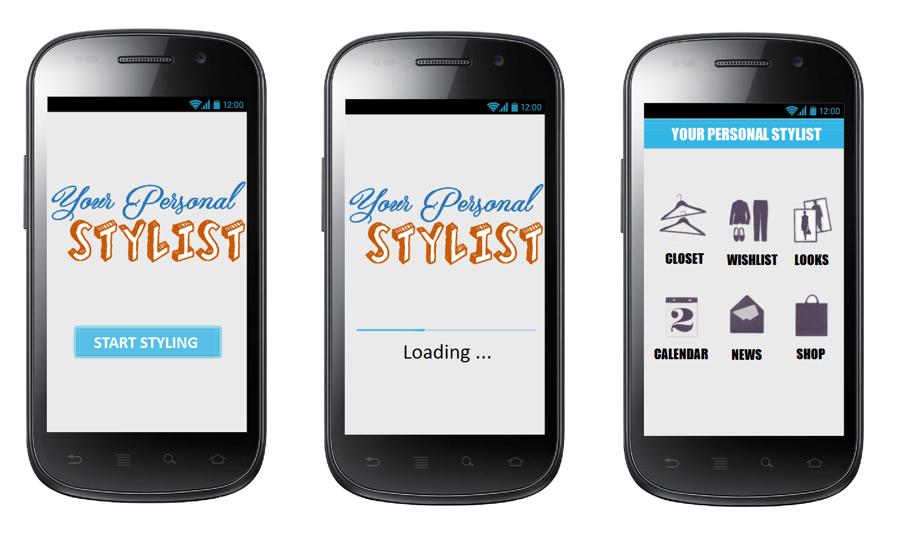

UI Mockups for Main Screen, Splash Screen and Home Screen

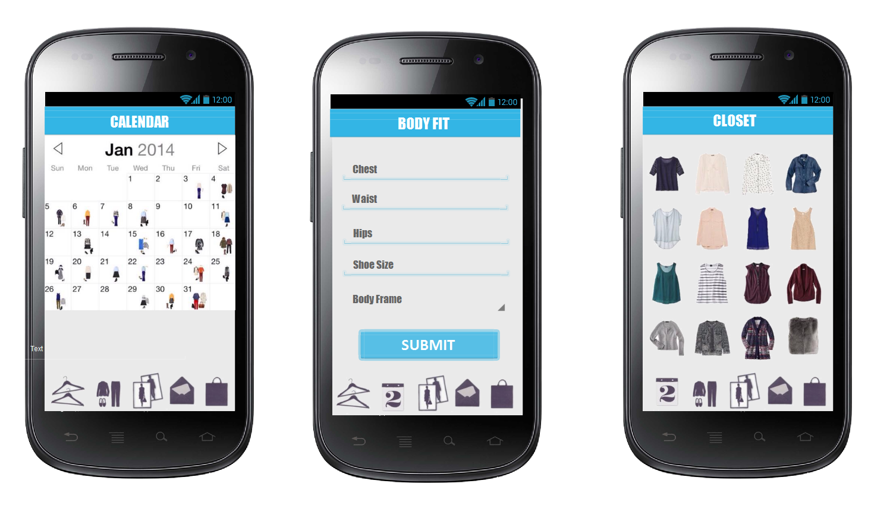

UI Mockups for Calendar, Entry of Vital Statistics, and Virtual Closet

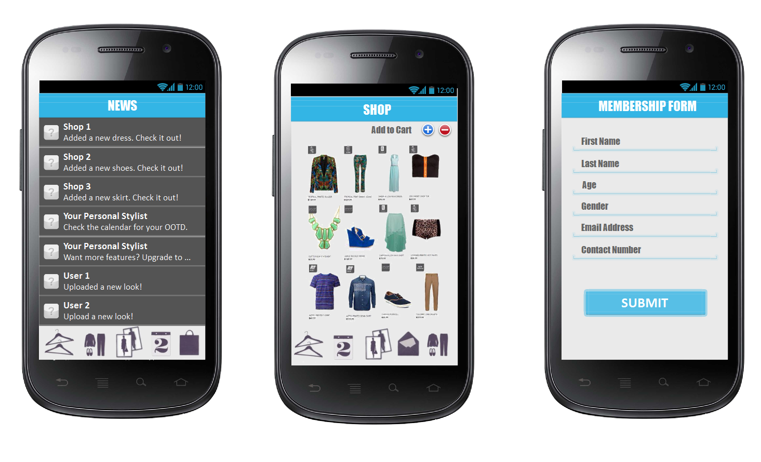

UI Mockups for News Feed, Shopping List and Membership Form

Maps & photos of location

**Studio Type Apartment in Mandaluyong**

Address: 479 Maysilo Circle Mandaluyong City.

Near Tapa King, LBC and Chooks-to-Go in Maysilo

29 sq. meters

  

Pictures of the Unit in Mandaluyong

List of assets available as collateral for a loan

|  |  |  |  |  |
| --- | --- | --- | --- | --- |
| Collateral for Loans |  | Value |  | Description |
| Real Estate |  | Php1,500,000.00 |  | Dimapilis Residence, Fourth Estate, Parañaque |
| Real Estate |  | Php4,000,000.00 |  | Urquiza Residence, Western Bicutan, Taguig City |

Market research studies (Magazine and other articles)

|  |  |
| --- | --- |
| Study / Article | Link |
| How Much Do Average Apps Make | <http://www.forbes.com/sites/tristanlouis/2013/08/10/how-much-do-average-apps-make/> |
| Facebook Advertising Cost | <http://www.jonloomer.com/2012/08/06/facebook-advertising-cost/> |
| Cost Helper Signage for Small Businesses | <http://smallbusiness.costhelper.com/signage.html> |
| Google Support (Wallet) | <https://support.google.com/wallet/business/answer/1619772?hl=en> |
| How To Put Your App In Google Play | <http://support.andromo.com/kb/distributing/how-to-put-your-app-in-google-play> |
| Google Play Support (Developers) | <https://support.google.com/googleplay/android-developer/answer/112622?hl=en> |
| Everything Developers Need To Know About App Store Transaction Costs | <https://blog.sensortower.com/blog/2014/03/05/everything-developers-need-to-know-about-app-store-transaction-costs/> |
| 5 Tips: For Your App to Chart Google Play in Android | <http://readwrite.com/2013/05/24/5-tips-google-play-charts-apps-android> |
| Starting A Business In The Philippines | <http://www.doingbusiness.org/data/exploreeconomies/philippines/starting-a-business> |
|  |  |